**POSHAN ABHIYAN**

*A*

*Mini Project Report*

*Submitted in partial fulfilment of the*

*Requirements for the award of the Degree of*

**BACHELOR OF ENGINEERING**

IN

**INFORMATION TECHNOLOGY**

By

**Y. AJAY KUMAR : 1602-20-737-002**

**R.THIRUPATHI : 1602-20-737-031**

# C.SAMIKSHA : 1602-20-737-037



**Department of Information Technology**

# Vasavi College of Engineering (Autonomous) VASAVI COLLEGE OF ENGINEERING (AUTONOMOUS)

**(AFFILIATED TO OSMANIA UNIVERSITY) HYDERABAD - 500 030**

## Department of Information Technology



## DECLARATION BY CANDIDATE

We, **Y.AJAY KUMAR, R.THIRUPATHI, C.SAMIKSHA,** bearing hall ticket number, **1602-20-737-002,1602-20-737-031,1602-20-737-037** hereby declare that the project report entitled **POSHAN ABHIYAN .**Department of Information Technology, Vasavi College of Engineering, Hyderabad, is submitted in partial fulfillment of the requirement for the award of the degree of **Bachelor of Engineering** in **Information Technology**

This is a record of bonafide work carried out by me and the results embodied in this project report has not been submitted to any other university or institute for the award of any other degree or diploma.

**Y.AJAY KUMAR : 1602-20-737-002**

**R.THIRUPATHI : 1602-20-737-031 C.SAMIKSHA : 1602-20-737-037**

**VASAVI COLLEGE OF ENGINEERING (AUTONOMOUS)**

**(AFFILIATED TO OSMANIA UNIVERSITY) HYDERABAD - 500 030**

## Department of Information Technology



## BONAFIDE CERTIFICATE

This is to certify that the project entitled “**POSHAN ABHIYAN**” being submitted by

**AJAY, THIRUPATHI, SAMIKSHA** bearing **1602-20-737-002, 1602-20-737-031, 1602-20-737-037**, in partial fulfillment of the requirements for the completion of MINI PROJECT of Bachelor of Engineering in Information Technology is a record of bonafide work carried out by them under my guidance.

Internal Guide External Examiner Dr.K Ram Moahn Rao

Mr. Chakravarthy HOD, IT

**ACKNOWLEDGEMENT**

We thank the department of INFORMATION TECHNOLOGY, for introducing the subject “Mini Project-2” in BE fifth semester.

We would also like to show our appreciation to our Honorable principal, Dr S V Ramana sir, our HOD K. Ram Mohan Rao for supporting us and our mini project lecturer, Mr. Chakravarthy Sir, for letting us properly understand the process of doing a project and for providing valuable insight and expertise that has greatly assisted us in the making of the project.

**TABLE OF CONTENTS:**

## 1 INTRODUCTION

1.1 PURPOSE

1.2 INTENDED AUDIENCE

1.3 PRODUCT SCOPE

1.4 PROBLEM DEFINITON

## 2. RELATED WORK

## 3. PROPOSED WORK

### 3.1 USE CASES

### 3.2 UI PROTOTYPES OR SCREENSHOTS

### 3.3 ARCHITECTURE

### 3.4 DESIGN

### 3.5 IMPLEMENTATION

3.5.1 MODULES

3.5.2 ALGORITHMS USED

3.5.3 CODE AND GITHUB LINKS

3.6 TESTING

4. RESULTS

5. DISCUSSION AND FUTURE WORK

6. REFERENCES

# ABSTRACT

* India’s malnutrition rates have dropped dramatically, the govt. of India has approved the centrally sponsored scheme ‘Pradhan mantra poshan Shakti nirman(PM POSHAN)’ for providing one hot cooked meal in government and government aided schools from 2021-22 to 2025-26.
* The primary goal of our project is to monitor if the necessary number of calories have been delivered to students in schools. We will also monitor each student's attendance depending on the meals that have been provided for them.
* This AI-based tracker captures a picture of the food being consumed and determines how many calories are in it. If the required number of calories are consumed, the child's attendance will be recorded.

## CHAPTER 1 INTRODUCTION

**What is a Poshan Abhiyan?**

PM POSHAN is a mid-day meal programme that provides kids in classes 1 through 8 in all public and government-aided schools with one hot, wholesome meal. From 2022 to 2023, students from the Balvatika pre-primary class will also be involved. During the school day, these meals are served once daily. Each kid is required to consume 450 calories and 12 grammes of protein at the primary level and 700 calories and 20 grammes of protein at the higher primary level each day. This initiative has a beneficial effect on keeping pupils in schools, according to independent review. Each child's participation in school and use of POSHAN must be monitored, as well as how this affects each child's physical health and overall wellbeing.

* 1. **PURPOSE**

The focus of Abhiyaan is to lay emphasis on nutritional status of adolescent girls, pregnant women, lactating mothers and children from 0-6 years age.

### 1.2 INTENDED AUDIENCE

The intended audience for this project is everyone who wants to know about

POSHAN SCHEME.

Any college website will have two types of users-

1. Schools
2. Website visitors either for inquiry or gathering information.

### 1.3 PRODUCT SCOPE

**Poshan abhiyan helps to the government to track the meals served for the students.**

**1.4 PROBLEM DEFINATION**

PM POSHAN is a mid-day meal programme for giving one hot cooked and nutritious meal to students of class 1 to 8 in all Government and Government-aided schools. Students from pre-primary class (Balvatika) will also be included from the year 2022-23. These meals are given once every day in school during school days. It is mandated that each child should get 450 calories and 12 grams protein at primary level and 700 calories and 20 grams protein at upper primary level per day. Third party evaluation has shown that this programme has a positive impact in retention of students in schools We need to track each child attendance and taking of POSHAN and the consequent impact on physical health and well-being as this has a direct co-relation to cognitive growth of the child We would also like to know the weekly Menu of each school, so that we are clear that the requisite calories are being served to each child We will perhaps need random photographs of meals being served The tracking at school, district, State and national level will be needed with the help of AI based tracker App-based solution.

## CHAPTER 2 RELATED WORK –

To detect food type by using convolutional neural network (CNN). Own dataset of meals are prepared for model training. Food items like pappu, curd and rice are used and their calories are predefined for detection.

## CHAPTER 3 PROPOSED WORK –

## 3.1 Use cases –

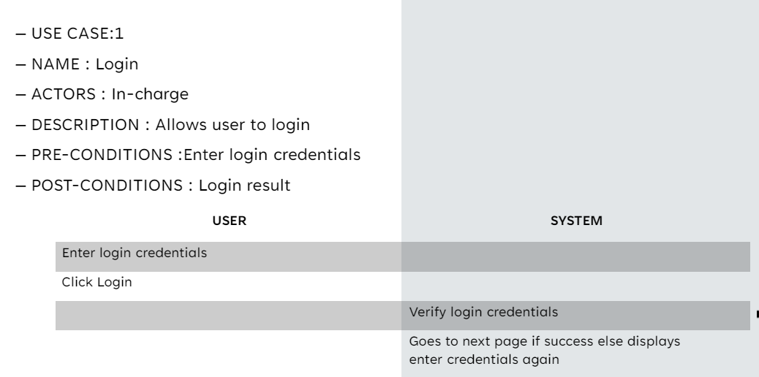

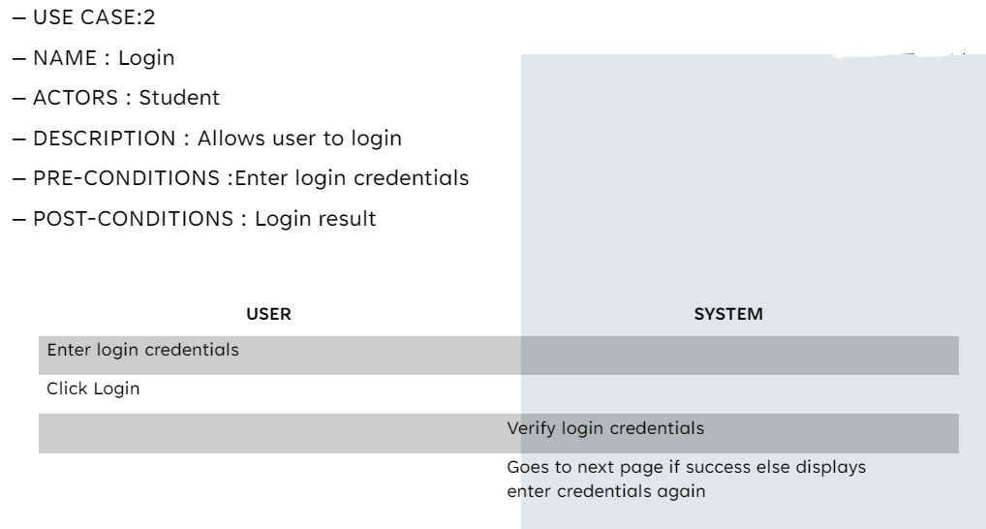

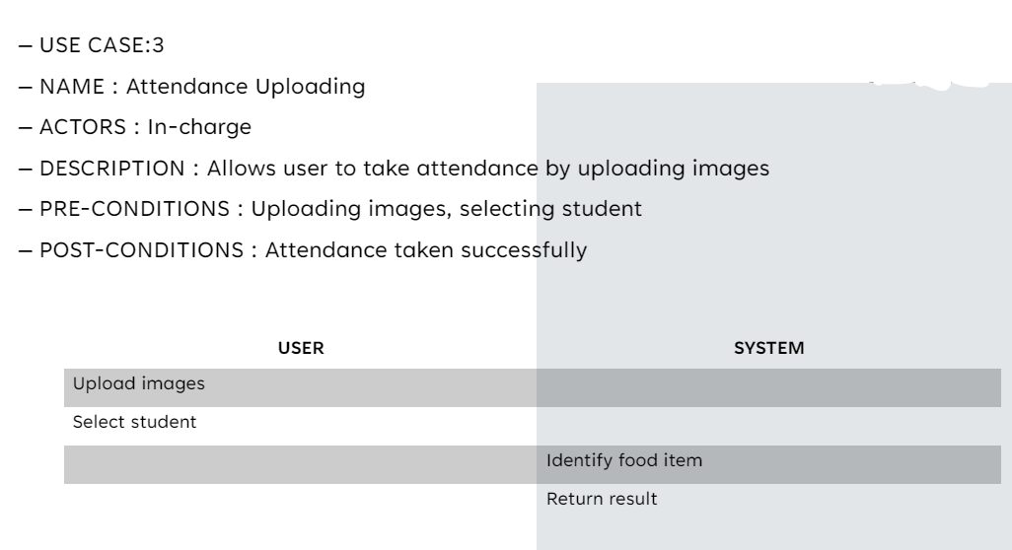

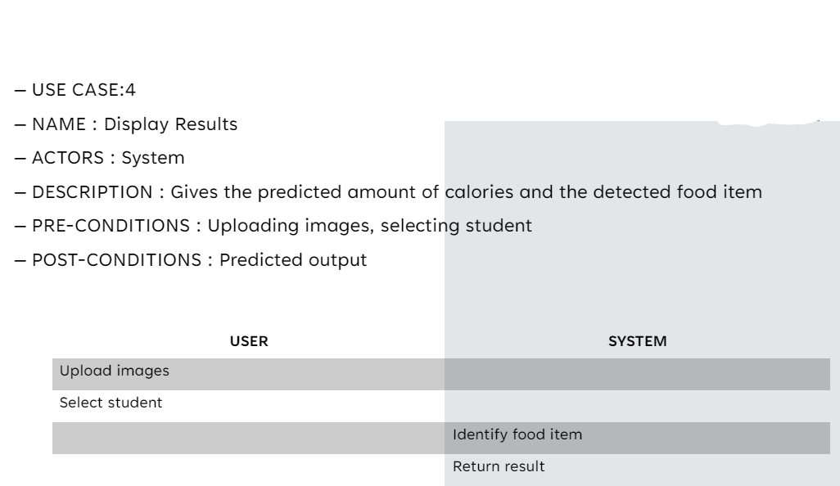

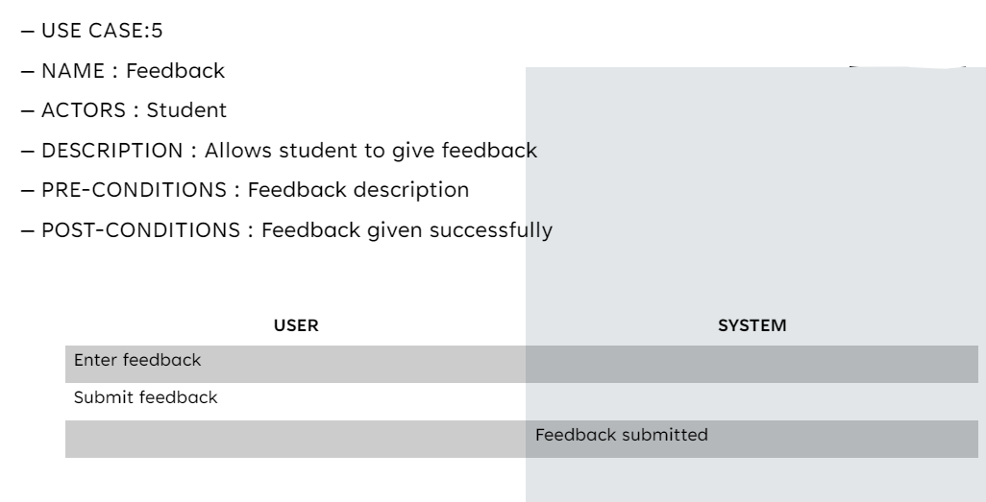

## 3.2 UI prototypes or screenshots

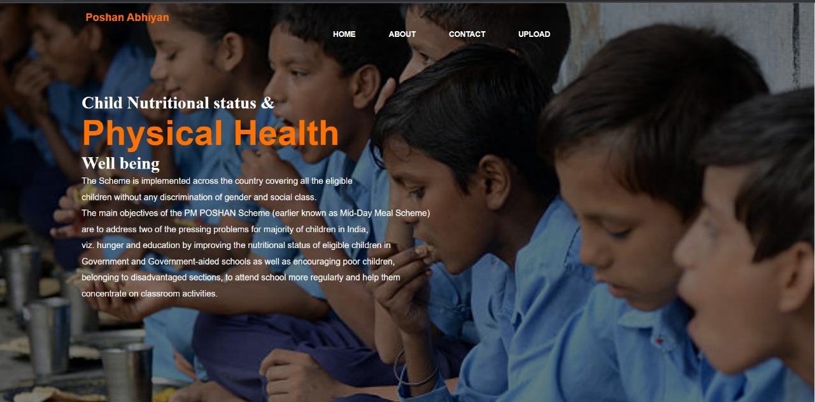

## 3.3 Architecture and Technology used –

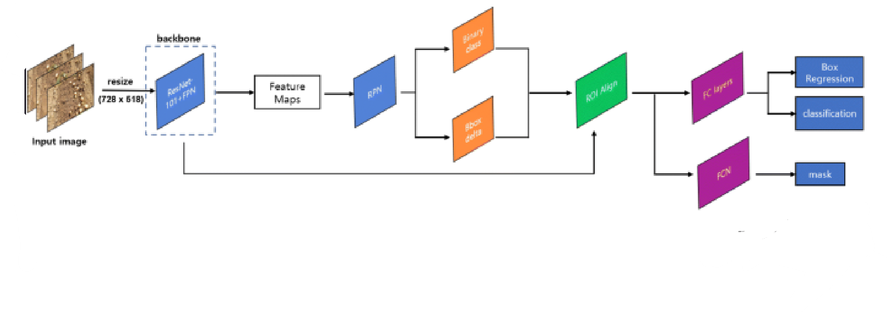

**Technology used –**

The project is done using HTML, CSS, JavaScript and Python.

**3.4 Design –**

**DATA FLOW DIAGRAM**

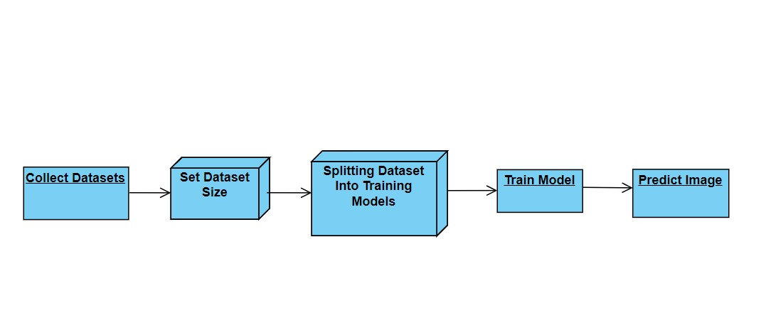

**USE CASE DIAGRAM**

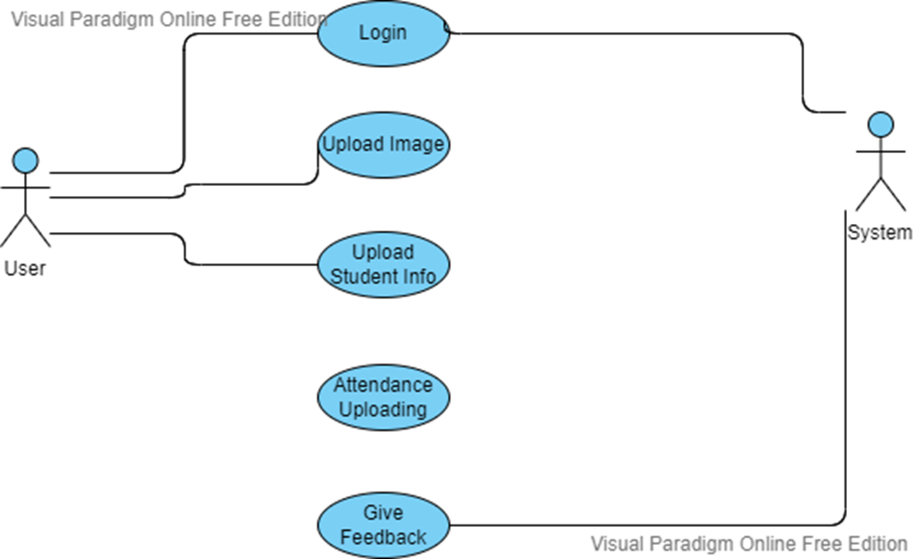

## 3.5 Implementation –

3.5.1 – Code –

<!DOCTYPE html>

<html lang="en">

<head>

<title>Children nutrional health status and physical health </title>

<link rel="stylesheet" href="style.css">

</head>

<body>

<div class="main">

<div class="navbar">

<div class="icon">

<h2 class="logo">Poshan Abhiyan</h2>

</div>

<div class="menu">

<ul>

<li><a href="#">HOME</a></li>

<li><a href="about.html">ABOUT</a></li>

<li><a href="contact.html">CONTACT</a></li>

<li><a href="upload.html"> UPLOAD</a></li>

</ul>

</div>

</div>

<div class="content">

<br>

<br>

<br>

<h1>Child Nutritional status & <br><span>Physical Health</span> <br>Well being</h1>

<p class="par">The Scheme is implemented across the country covering all the eligible<br> children without any discrimination of gender and social class.<br> The main objectives of the PM POSHAN Scheme (earlier known as Mid-Day Meal Scheme) <br>are to address two of the pressing problems for majority of children in India,<br> viz. hunger and education by improving the nutritional status of eligible children in <br>Government and Government-aided schools as well as encouraging poor children,<br> belonging to disadvantaged sections, to attend school more regularly and help them<br> concentrate on classroom activities.</p>

<div class="form">

<h2>Login Here</h2>

<input type="email" name="email" placeholder="Enter Email Here">

<input type="email" name="email" placeholder="Enter Password Here">

<button class="btn"><a href="#">Login</a></button>

<p class="link">Don't have an account</p><br>

<a href="#">Sign up</a> here</a></p>

<p class="liw">Log in with</p>

</div>

</div>

</div>

</body>

</html>

from google.colab import drive

drive.mount("/content/gdrive")

import os

if not os.path.isdir("TheCodingBug"):

  os.makedirs("TheCodingBug")

import os

if not os.path.isdir("yolov7"):

  #os.makedirs("TheCodingBug")

  !git clone https://github.com/WongKinYiu/yolov7.git

!git clone https://github.com/facebookresearch/detectron2.git

!pip install -e detectron2

!python train.py --workers 1 --device 0 --batch-size 16 --epochs 100 --img 640 640 --hyp data/hyp.scratch.custom.yaml --name yolov7-custom --weights yolov7.pt

!python detect.py --weights runs/train/yolov7-custom2/weights/best.pt --source 7e64bf52560075814bb49fbf06bf6d26.jpg

**3.5.3 – GitHub Links –**

https://github.com/samiksha-08/food-calorie.git

**3.6 – Testing –**

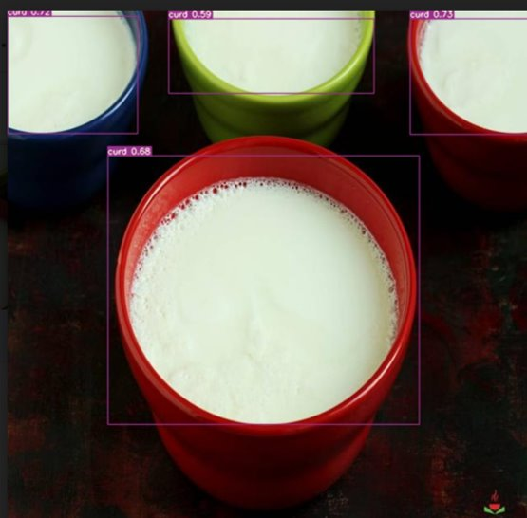

## CHAPTER 4 – RESULTS

The following are the results obtained after implementation –



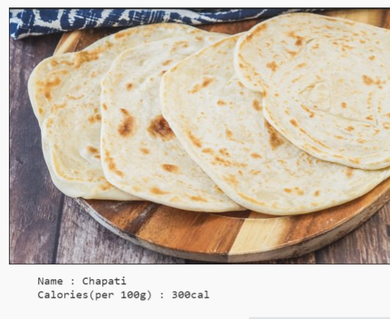

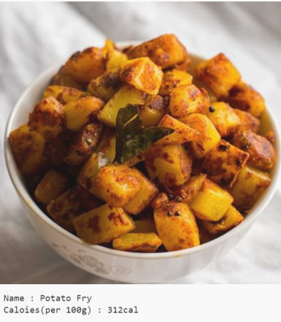

**CHAPTER 5**

**DISCUSSION AND FUTURE WORK –**

* We will improv calorie estimation using instance segmentation, which will help calculate the precise amount of calories present.
* We will include image based IBM index calculation which will help automatic calculation of the height and weight
* We will implenent it as an android application

## CHAPTER 6 REFERENCES –

* <https://www.w3schools.com/html/>
* <https://www.w3schools.com/css/default.asp>
* <https://www.w3schools.com/js/default.asp>
* <https://www.w3schools.com/python/default.asp>
* <https://roboflow.com/>
* <https://www.kaggle.com/>